

Study Guide for Mentors of Team Members

OpenAgile by http://www.openagile.com/ is licensed under a Creative Commons Attribution-No Derivative Works 2.5 Canada License (View at: http://creativecommons.org/licenses/by-nd/2.5/ca/).
Copyright 2010

Version 0.1

Foundation One: Truthfulness
“Truthfulness is the foundation of all human virtues” - 'Abdu'l-Bahá

According to the OpenAgile Primer, how can we develop our capability to be truthful?

Truthfulness is more than an ethical standard. Which of the following are aspects of truthfulness? Circle them:
honesty
cheating
being forthcoming
openness
stealing
cutting corners
transparency
self-awareness
lying
doing what we say we will do
keeping our commitments to our team

What is the difference between transparency and visibility?

What does the lack of truthful behaviour do to us or our work environment?

How do we get better at truthfulness?

Why is truthfulness necessary? Circle as many of the following that apply:
learn from mistakes
being creative
find an effective approach to doing work
building trust
reducing excessive bureaucracy
reducing chaos

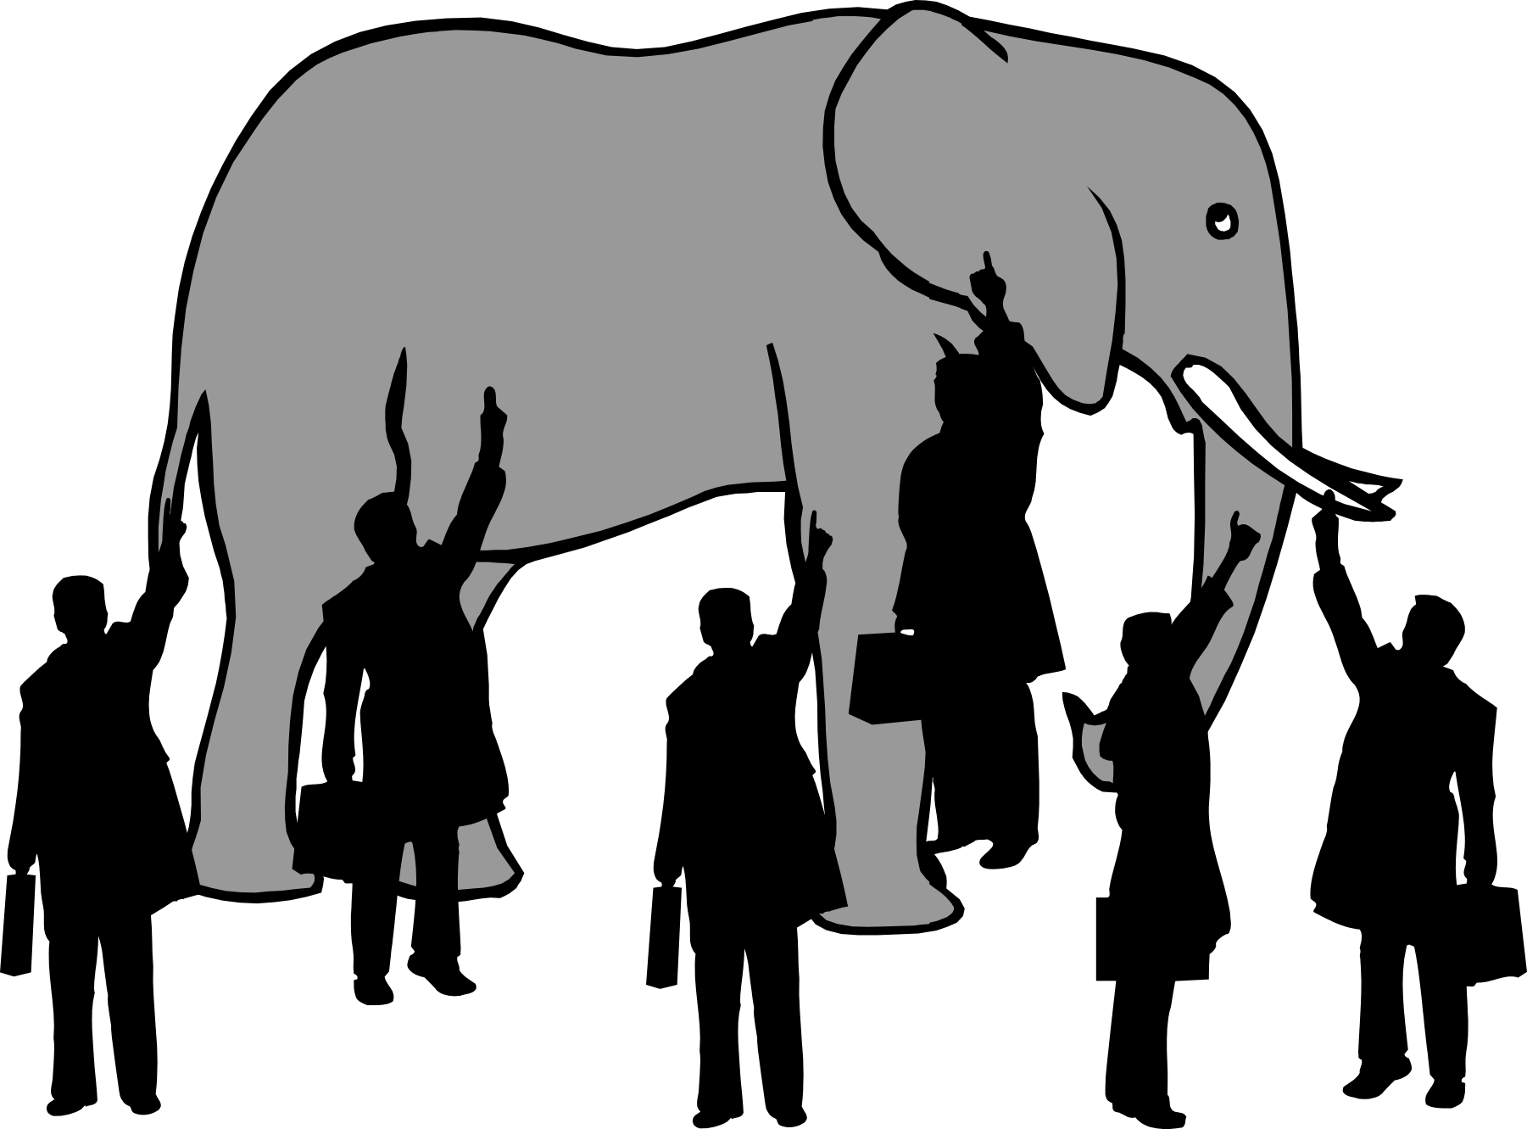

“You may know the story of the six blind men and the elephant. Each blind man is touching a different part of the elephant. One is touching the tusk and thinks that it is a spear. Another is touching the leg and thinks it is a tree trunk. If you tell them that they are all touching the same thing, it is very likely that they will argue about what it is. Unless they are also truthful about their own limitations, it will be difficult for them to come to a unified vision about what they are touching. This is the deepest kind of truthfulness: knowing your own limitations.”

Why is the deepest kind of truthfulness knowing your own limitations?

“The filters we have as we perceive the world are important: they reflect our beliefs and help us sort the world efficiently. However, these filters can also hinder us and become blind spots or prejudices that prevent us from being open to the truth. In an OpenAgile environment, we strive to be open to the way other people perceive the world so that we can learn from them.”

Do we all have filters?

Why is it important to understand how we perceive the world around us?

Why is truthfulness one of the foundations of OpenAgile?

Foundation Two: Consultative Decision-Making
"We never undertook to do any thing of any importance which was likely to affect each other, without mutual consultation. We were generally a unit, and moved together." - Frederick Douglass

Why is a unified vision important?

What does it mean to take coherent action?

What frame of mind should you have when you are applying Consultative Decision-Making?

Why are “truthfulness, humility, and detachment” important for helping a team make decisions?

-----

Consultative decision-making is a method for individuals, teams and organizations to take coherent action based on a unified vision. The process requires that all people involved in making a decision put themselves into a new frame of mind where truthfulness, humility and detachment are uppermost, rather than competition, debate and arguing. This means that after a decision is made, all those involved will fully support the decision, not just giving lip-service, but wholeheartedly acting in accord with the decision.
Rules of Consultative Decision-Making
Consultative decision-making is based on the following simple rules:
- Everyone is encouraged to contribute to the discussion; a diversity of views is welcomed
- No idea is owned by any individual and therefore it is okay to change your own mind
- Offence should never be given nor taken
- Personal attacks are absolutely forbidden; Aggressive interruption is considered bad behaviour
- Everyone should be able to fully express themselves in a frank, amicable, and courteous manner
Unified Action
Discussion ideally results in unanimous support for a line of action. However, if unanimity is not possible, a majority can carry a decision. In this case, though, once a decision is made, regardless of whether or not you voted for it, you fully support the decision. The reasoning is simple: by fully supporting the decision in unified action, whether or not the decision is correct, through reflection, a better way will become clear. Adjustments can then be made based on collectively learning about better approaches through experience.
Consultative decision-making can be used in all aspects of the OpenAgile process, it requires Truthfulness, and it is an essential component of OpenAgile.
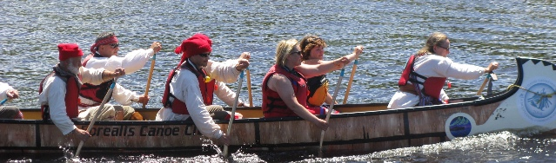
Photo credit: Darin Zandee

Foundation Three: The Learning Circle
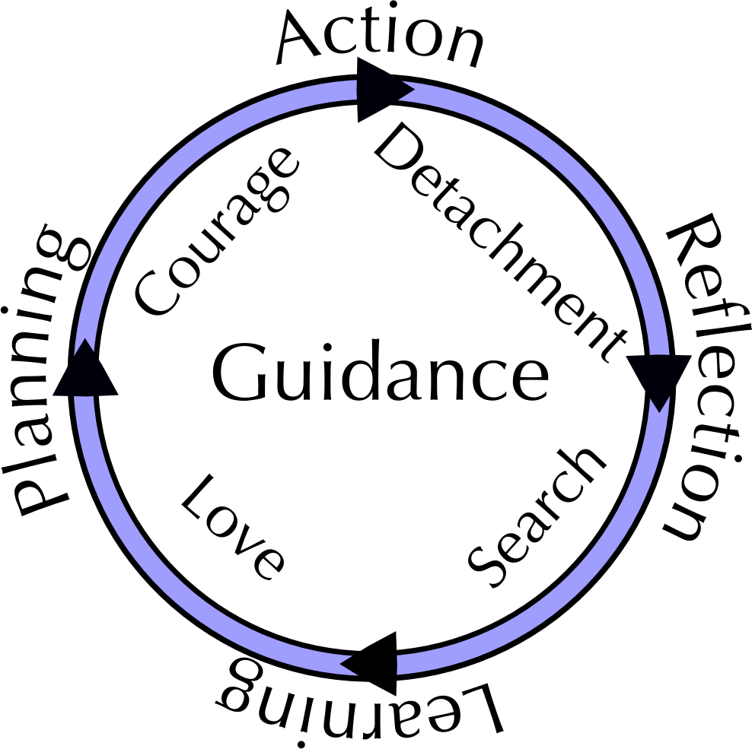
“Learning is like rowing upstream: not to advance is to drop back.” - Chinese Proverb

The Learning Circle is a simple and practical model of effective learning. This model describes learning as a series of four steps for us to follow, four capacities for us to develop, and the pivotal importance of Guidance. The steps are repeated over and over thus giving us the opportunity to get better at learning and to make progress. The Learning Circle model applies to traditional operations and project work as well as primary learning environments such as research and innovation.

The Four Steps
The four steps in the Learning Circle are Reflection, Learning, Planning, and Action, and are followed one after another, over and over. It is possible to begin an endeavour with any of the four steps. The diagram below shows the Learning Circle Model:

- Reflection
The Reflection step is a pause in our activities where we gather data, impressions, history, stories, and any other observations about what we have done. In order to do this effectively, we must develop and exercise the capacity for Detachment – detachment from preconceived notions.
- Learning
In the Learning step we carefully examine the observations made in the Reflection step and "discover" new insights, skills, relationships, structures, failures or any other conceptual changes. We search for the principles involved in our work. In order to do this effectively, we must develop and exercise the capacity of Search – search for the underlying principles.
- Planning
In the Planning Step we apply the conceptual understandings we have developed. We create a plan of action using the newly discovered principles from our learning step. We should directly reflect in our planning each insight or principle we have learned. In order to do this step effectively, we must develop and exercise the capacity for Love – love for the act of learning.
- Action
In the Action Step, as an individual, team, or organization we carry out the plans we have created. We do our work. In order to do this effectively, we must have Courage – courage to plunge into the unknown.
The Four Capacities
Each of the four capacities in the Learning Circle are prerequisites for taking the next step. At the same time, as we exercise these capacities through the use of the Learning Circle, we develop these capacities within ourselves, in our teams and in our organizations. Our inner conditions and capabilities have an effect on our environment which in turn then has an effect on us. By going through the Learning Circle, we use and develop these four capacities:
- Detachment. The capacity for Detachment supports the Reflection step. Detachment is openness. Detachment means that we set aside our ego and objectively look at the evidence including facts, events and feelings.
- Search. The capacity for Search supports the Learning step. Search includes consultation, wisdom, discernment, judgement, and search for solutions.
- Love. The capacity for Love supports the Planning step. Love of learning creates openness to Guidance. Love engenders vision, passion, and a sense of purpose.
- Courage. The capacity for Courage supports the Action step. Courage encompasses conscious choice, volition, willingness, and desire to act even in the face of uncertainty.
In the beginning, we may not be strong in these capacities. However, with practice in the Learning Circle, we have the opportunity to grow and become comfortable with the Four Capacities. As they say “practice makes perfect.”
Guidance
Central to the effectiveness of the Learning Circle is the concept of Guidance. Guidance is the act of assisting an individual, team, or organization to reach a destination by accompanying, giving directions, or supplying advice. Guidance plays a pivotal role in developing our capacity and can be applied to all four steps and all four capacities. For individuals, teams, and organizations, Guidance is critical to be able to progress in the development of knowledge, skills or capacities. Guidance can come from within – a team member who has expertise can share it with the other team members. And Guidance can come from outside – we can bring experts into the organization, we can read books or web sites. Inspiration can also be thought of as a form of Guidance, for example a team member suddenly has a bright idea. Being open to receiving Guidance ensures that the Learning Circle is both organic and disciplined.

Chapter 2 – The OpenAgile Process
The processes in OpenAgile are designed so that individuals, teams, and organizations can apply the Learning Circle in a systematic manner.

Goals
All work is done for a reason, to achieve a purpose, and to accomplish a goal. OpenAgile is a framework for helping us do this as effectively as possible.
In OpenAgile, goals can be lofty or practical, simple or complex, short or long term. It is natural for goals to start broad and become more specific as you make progress. Having a goal allows you to track progress, contextualize feedback, and ensure that the work you are doing is valuable.

Work in Cycles
In OpenAgile all work is done in short Cycles of equal length. Every Cycle can be considered a single step along the path to our goal of producing valuable results. Each Cycle of work builds on the value you created in the previous Cycle. There are three rules to doing this effectively. First, apply the Learning Circle without fail, every Cycle. The Learning Circle encourages the systematic evaluation of our assumptions, actions, and outcomes. Second, use Cycles of equal length. This allows us to measure our progress across Cycles. Third, use Cycles that are short relative to the length of your Goal. Short Cycles, ensure that you frequently deliver value to stakeholders, adapt to change, and emphasize continuous improvement. If you have a goal that is one year away, you might choose Cycles that are one month long. If your goal is only one week away, you might choose Cycles that are four hours long.
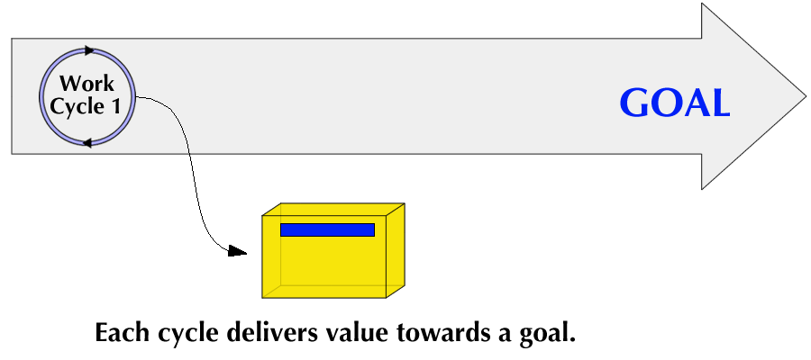

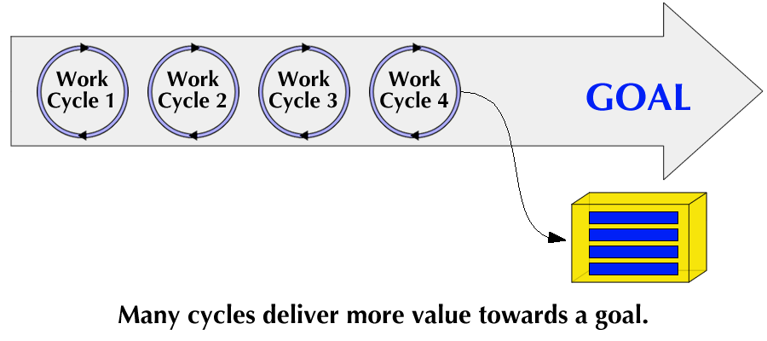

Cycle Input: Value Drivers
At the outset, we need a measurable activity or focus to help drive our progress towards accomplishing our goals. We call these Value Drivers. When achieved, a Value Driver should result in delivering something of value to your stakeholders. Value is defined as a characteristic deemed desirable by stakeholders that is measured in relation to a goal and verified by achieving the intended results by the end of a Cycle.
A Value Driver is best understood when it is S.M.A.R.T. – specific, measurable, attainable, results-oriented, and time-bound. We cannot predict the future, so it is important to work on the highest priority Value Driver first. The Growth Facilitator, which we will discuss in greater detail later, is responsible for collecting and prioritizing the list of Value Drivers.
Traditional Value Delivery
Delivering value every Cycle is not always easy. In some environments, we treat reaching a goal as a whole project in which we plan the project at the start, execute the project and then assess whether we have reached the goal. This is a traditional project management approach, but when we use this approach there is usually no second chance. We make it or we don't. There is no ability to react gracefully to change because of the high cost of rework. In OpenAgile, the use of Cycles is deliberately designed to give us lots of chances to truly assess if we are contributing to the goal.
Organic vs. Mechanical Value Delivery
A great analogy to help explain this concept is to look at mechanical systems and organic systems. A mechanical system like a car doesn't grow. It is assembled. A car is made up of many components that are critical to its function – an engine, tires, steering wheel. But if you are missing the engine, the car has no value as a car. You can't easily manufacture a car in small stages so that even the first stage has essential car-ness. Instead, a car only makes sense at the end when all the pieces are put together.
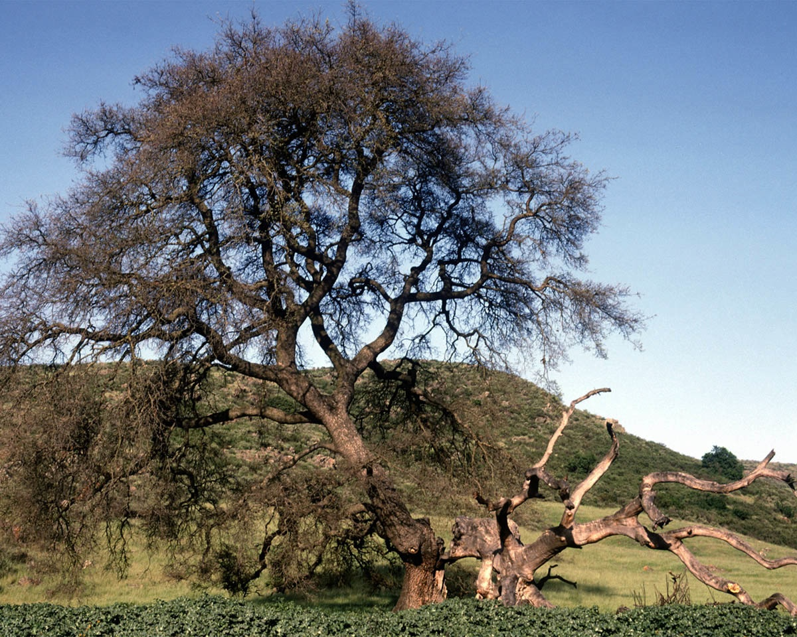
On the other hand, if you look at a tree, every year right from the time it is a seedling, it retains its essential tree-ness. Moments after the seed has sprouted, you can call it a tree. As it grows, there is no point in time when it is not a functional tree. Even if a branch breaks off, it is still a tree.
Mechanical systems respond poorly to change. Change can even be catastrophic for a mechanical system. However, organic systems are much more adaptive to change. OpenAgile is a means for humans working together to respond to change in a way that is more like an organic system rather than a mechanical system.

Value and the Learning Circle
The parts of the sequence of the Learning Circle after Action, namely, Reflection, Learning and Planning are required to ensure that we are still contributing value. We ensure that our goal is still valid, we are doing things the best way we know how, and we adjust all these things if needed. This may mean that parts of what we have done in the first Cycle get changed immediately, or that new ideas are generated that weren't possible at the start, or even that the goal is changed entirely! This kind of change is only possible if we are fully open to the possibilities revealed through the Learning Circle by using it every single Cycle. The Learning Circle gives us a model that even allows us to change our goal if we discover the need to do so.

Engagement Meeting
We begin every Cycle with an Engagement Meeting. In the Engagement Meeting, we focus on Reflection and Learning followed by Planning. We use Consultative Decision-Making to explore all the items in our list of Value Drivers and decide which of these will be done in the current Cycle. We break down each Value Driver into as many independent tasks as are necessary to satisfy the stakeholder.
The result of this meeting is called a Cycle Plan. The Cycle Plan consists of a number of tasks that we do during the Cycle. We will discuss the Core Types of Tasks in greater detail later.
Timing
The Engagement Meeting is the same length of time every Cycle and it is in proportion to the overall duration of the Cycle. For example, a one-week long Cycle for a business would have an Engagement Meeting that lasts between two and four hours, but really shouldn't be longer than that. If there are forty working hours in the Cycle, then the meeting should be two to four hours long. In other words, less than one tenth the overall Cycle duration. If a Cycle is only one workday long, then the Engagement Meeting should be less than forty-eight minutes long. And if the Cycle is three months long, but it is for a volunteer group working on average ten hours per week, then the Engagement Meeting should be less than twelve hours long (12 weeks x 10 hours/week x 10%).
Keeping the meeting short relative to the overall length of the Cycle helps maintain focus. As we go through this meeting, we should not consider the stages of Reflection, Learning and Planning as strict agenda items. Rather, we start the meeting with a focus on Reflection, but some Learning and Planning may take place right at the start. As we progress through the meeting, the emphasis shifts to Learning, and then shifts finally to Planning. As an example of how this might look, consider that you might have forgotten an important fact about the previous Cycle which you only remember near the end of the Engagement Meeting. Rather than rigidly sticking to just planning, you would be welcome to bring up this recollection since it may be important to making an effective Cycle Plan.
Engagement Meeting Output
The output of the Engagement Meeting is a Cycle Plan. The Cycle Plan consists of a collection of tasks. Tasks can be recorded in any manner that is effective for the environment. For example, if we are a small team working in a common space together, then we might record tasks on note cards and put them on the wall so that everyone can see them. On the other hand, if we are working with people we never see because we are dispersed over a large geographic region, then perhaps using an electronic tool such as a wiki or spreadsheet is more appropriate.
Reflection During the Engagement Meeting
In the Engagement Meeting, we typically start with Reflection. Reflection can include seeing a demonstration of work completed in the prior Cycle. It can include personal time to reflect on how we felt and what we did in the prior Cycle. It can include examining the completed tasks of the Cycle Plan for the prior Cycle. Reflection during the Engagement Meeting typically lasts between ¼ and ½ of the overall time of the Engagement Meeting. However, there is no strict rule about how much time we should spend on Reflection.
Learning During the Engagement Meeting
As we are Reflecting on our prior Cycle, we will notice things that are deeper than just what happened – the things we have learned. Learning typically follows Reflection, but there can be some overlap: some of us are still Reflecting, and others of us are realizing what we have learned. We should take care to clearly identify what we have learned so that everyone involved can appreciate our collective and individual capacity building. Moreover, we pause to ensure that we use what we have learned to make our Cycle Plan as effective as possible. Like Reflection, Learning in the Engagement Meeting typically takes between ¼ and ½ of the time.

Cycle Plan
The last part of the Engagement Meeting is Planning, or the act of creating the Cycle Plan. The Cycle Plan is simply a collection of all the tasks we intend to do during the Cycle in order to deliver value. We ask questions and discuss what is required to complete each Value Driver, and we deliberately use our Reflections and Learnings to shape our understanding of the intended outcomes. A Cycle Plan should be tempered with a truthful assessment of our capacity to complete the tasks.
A Note About Perfection
The Cycle Plan is not intended to be perfect. We don't have to follow it rigidly, which in most types of work would lead to disaster. The Cycle Plan is meant to be flexible. One of the key ways in which it is flexible is that we do not decide who will do what task at the start of the Cycle. Instead, we decide as we go. As the team works, tasks are completed, modified, new ones are added to the Cycle Plan, shared, or deleted.
Generating Tasks
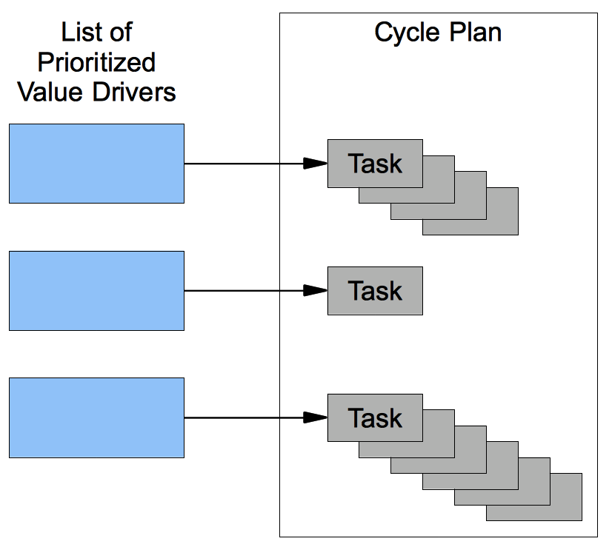
In the Engagement Meeting, everyone participating in the work of the Cycle needs to actively participate in generating tasks. This creates collective ownership of the Cycle Plan. Generating tasks can be done in a discussion format or with people working individually and then coming together at the end of the meeting. Generally, any item in the list of Value Drivers can become many tasks. For example, if one of the Value Drivers is to have a meeting with a potential client, then this single item might result in three tasks: confirm the meeting, prepare the agenda, and then hold the actual meeting. The way Value Drivers become tasks is entirely up to the people involved in doing the work. People who will not be working during the Cycle do not have a say in defining the tasks in the Cycle Plan.

The Core Types of Tasks
Let's look more closely at the Core Types of Tasks, which occur in our Cycle Plan.
Calendar Events
The first category of tasks contain those which are based on scheduled dates or times – Calendar Events. A meeting with a potential client, a trade show, a scheduled phone call, a team meeting. All these are Calendar Events and need to be accounted for in our Cycle Plan. At the start of the Cycle, we look at our personal and job-related calendars and create tasks that represent all Calendar Events that occur during the Cycle.
Typically, the Calendar Events do not include the meetings that are part of the OpenAgile process. For example, the Engagement Meeting, even though it happens at a specific date and time, is not considered one of the Calendar Events.
Repetitive Activities
Tasks in this category consists of things which must be done on a regular basis. For example, every month a report is created. Or every year, certain government documents need to be submitted. Or every week, plants in an office need to be watered. The tasks in this category are most closely related to day-to-day operations. These are habits we need to establish or attributes and qualities of our work that we need in order to be considered 'done'.
Repetition does not just refer to a time period. For example, there may be specific activities you take each time you get a lead for a new client. You don't know exactly when you will get new leads, but you do know that certain activities have to be repeated for each lead. Tasks in this category are most often represented by a list that states what the work is and how often it must be done. In planning a Cycle, we need to look at this list and see if anything in it needs to be brought into the Cycle Plan.
A Repetitive Activity is often written so that it can follow this template: “Every ____ we will _____.” For example, we might have a Repetitive Activity that says “Every day we will check voice mail.” Or, “Every new lead we will enter their contact information into our customer relationship management system.”
Quality Problems
Quality is closely related to Truthfulness. In OpenAgile, we strive to maintain a very high standard of quality, and to constantly work on improving that standard. Whenever we find a defect or an error in work we are doing or work we have delivered in previous Cycles, we must try to resolve the problem as soon as possible. When we plan our Cycle, we examine the work of previous Cycles to check if there are things we need to fix. If so, these repairs become part of our Cycle Plan.
Sometimes we encounter Quality Problems in the middle of a Cycle. Because quality is so important, we should strive to fix any known Quality Problems immediately. At Toyota, this is known as “stop the line”. If there is a defect noticed in a piece of work on the manufacturing line, any employee can pull a chain which will stop the whole production line. Then, staff do an analysis for the cause of the problem, fix it, and re-start the production line. It is critical to identify the root cause of a Quality Problem to prevent it from recurring.
Obstacles
Obstacles prevent us from getting work done efficiently. As we do our work, we encounter Obstacles. These Obstacles can be a lack of resources or knowledge, a physical obstacle, personality conflicts, organizational culture, or a number of other sources. We therefore need to identify and remove Obstacles. The OpenAgile system regards the overcoming of Obstacles as very high priority. This is critical for short-term productivity and long-term success. The Process Facilitator, which we will discuss later, is responsible for removing obstacles.
New Artifacts
New Artifacts hold a special place in OpenAgile because almost all work environments require the human capacity for creativity. New Artifacts are tasks which result in the creation of something concrete. These tasks channel our capacity for creativity into working towards our goal of adding value for stakeholders. The creation of a document, a process, or a tool, or changing existing documents, processes or tools are all examples of New Artifact tasks. A task in the New Artifacts category must be sized in such a way that, if it is worked on in a Cycle, it can be completed, verified to be complete, and is useful in relative isolation.
Commitment to the Cycle Plan
Everyone needs to participate in making a commitment to the work of the Cycle. This can be done in a number of ways, but in OpenAgile we focus on the idea of being truthful about our capacity. Deliberately over-committing is strongly discouraged. Instead, we carefully look at the quantity and quality of the tasks in our Cycle Plan. By considering everything together, we can learn to make reasonable commitments to our team members. There are many advanced techniques for measuring capacity and estimating the amount of work in a Cycle Plan. However, the simplest approach, and the one that we normally start with, is to have consensus agreement: everyone in the group must fully agree to commit to the whole Cycle Plan. If anyone is uncertain, then remove some work from the Cycle Plan until everyone is certain. By the end of the Engagement Meeting, everyone involved in doing the work of the Cycle should be fully committed to finishing all the tasks in the Cycle Plan.
Once we have a Cycle Plan that we are committed to, then we take Action.

Inside a Cycle
The OpenAgile system includes important structures for ensuring that a Cycle goes as smoothly as possible. Let's look in more detail at what should happen during a Cycle.
Every Cycle starts with the Engagement Meeting as we already mentioned. It includes Reflection, Learning and Planning. Following the Engagement Meeting we start working on completing tasks in the Cycle Plan. We participate in relatively brief Progress Meetings several times throughout the Cycle. These Progress Meetings are regularly spaced throughout the Cycle. The times between Progress Meetings in which we do our work are called Work Periods.
A Positive Attitude
A little detour to look at one of the principles of working in OpenAgile is appropriate here; we need to maintain a very positive outlook and inner condition. Tests and trials occur in all parts of our life, and maintaining a positive attitude is not always possible. However, we still strive to remain positive and seek opportunities to grow from all the challenges we encounter. This is not to say that we ignore problems. Rather, we accept that our inner condition can influence our environment, just like our environment can influence our inner condition. If we are happy, we express that happiness in many small ways that help the people around us to become happy. If we are content and calm, that inner feeling gets expressed in how we respond to others which in turn helps them to be content and calm. Similarly, if our environment is beautiful – if the words we hear, the music we listen to, and the things we read are positive, we are more likely to feel positive ourselves. Creating an positive inner condition is something that helps us use OpenAgile effectively.
In order to set the right tone for the Engagement Meeting, it is strongly encouraged that those people involved in the Cycle take a short amount of time to “check in” before beginning the work. This can be done as a group or individually and is intended to transition the group into a stronger sense of presence and connection to the work at hand. Try reading or reciting meaningful passages from uplifting sources to help orient your thoughts on the principles and attitudes needed. For example, try the following passage written by 'Abdu'l-Bahá:
“I will be a happy and joyful being. I will no longer be full of anxiety, nor will I let trouble harass me. I will not dwell on the unpleasant things of life.”
This short passage helps us to make our inner condition ready for an intense learning environment. Even though we might struggle or make mistakes, we are all trying our best to make progress. This outlook assists us to maintain a positive attitude that extends from the Engagement Meeting throughout the whole Cycle.
Volunteering for Tasks
Team members volunteer for tasks, usually taking on only one task at a time. No one on the team or outside the team is allowed to tell a person which task to do. This volunteering behavior is so that the team will be most effective: people will naturally volunteer to do tasks that they are most capable of.
Imagine you are working on a task in a Cycle, for example writing something for a client, and a team-mate finishes his work earlier than expected. He could sit idle, but this would be a waste of his time. Instead, he could look at the Cycle Plan and see what tasks are remaining. Perhaps there are a few, but they are all tasks that normally you would do. Does it make sense for your team-mate to wait while you do the the rest of the work for Cycle? OpenAgile asserts that all of us are able to learn. Your team-mate should choose a task, and if he does not know exactly how to do it, that's okay. It might take him longer to do it than it would take you, but you're busy anyway! By doing this task, your team-mate learns through experience (and possibly research), and therefore becomes a stronger contributor in future Cycles.
Tracking Progress
The Progress Meetings are similar to the Engagement Meeting in that they are very much about pausing to learn. The purpose of these meetings is to ensure that we are progressing through our Cycle Plan and that we will do the best job possible to complete it.
The Progress Meetings are brief. We don't want to interrupt our work too much, so we keep these meetings short compared to the amount of time between these meetings. The work time should be about 30 or 40 times longer than the time spent on these Progress Meetings. For example, if we wish to have a Progress Meeting daily, then it should only last about 15 minutes. Generally at this meeting, people take turns and focus on very practical, tactical responses to the Reflection, Learning and Planning parts of this meeting.
The Progress Meeting will potentially result in changes to the Cycle Plan and will also allow us to make sure that we are getting tasks done in a timely manner. We should see that gradually over the course of the Cycle, more and more tasks are completed and fewer and fewer are left to be completed. In general, the number of tasks remaining in the Cycle Plan should gradually get closer to zero as we approach the end of the Cycle. This is a good way of understanding if we have over-committed for a Cycle – if we can see that the number of tasks remaining is not going down quickly enough, we may be able to make adjustments to the Cycle Plan.
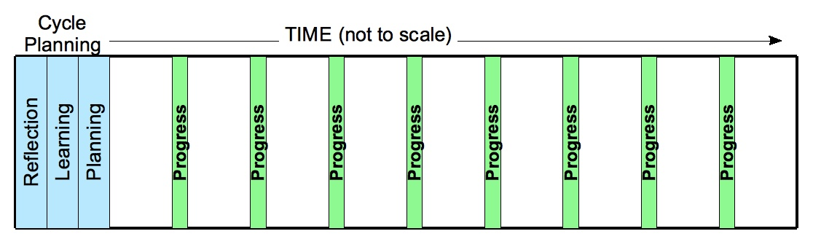
There should be at least four Progress Meetings in a Cycle. If there are fewer, then there are not enough opportunities to learn and to adjust over the course of the Cycle. Likewise, we generally should have fewer than twenty Progress Meetings in a Cycle. Too many of them and there won't be much actual progress and learning to discuss.

Chapter 3 – The Participants in OpenAgile
So far, we have focused on describing the OpenAgile process without focusing on who is responsible for what in the OpenAgile system. Because OpenAgile can be applied to the work of individuals, teams, and organizations, it is important to have a flexible system for how people participate. There is, in fact, only one role: the Team Member. Everyone who is involved in the work being done as part of the Cycle Plan is a Team Member, by definition. Likewise, if you are not doing work that is part of the Cycle Plan, then you are not a Team Member for that Cycle.

Paths of Service
There are many additional ways in which people can be engaged participants and serve a team or organization in OpenAgile. Depending on the needs of the Team Members, and the capacities they have built, people may arise to serve in the following ways:
The Process Facilitator
We recognize that sometimes it is helpful to have someone who can act as a Process Facilitator. This is a person (or possibly even a group) who can help us follow the rules of OpenAgile and develop our capacity to apply the principles of OpenAgile.
The Growth Facilitator
We also sometimes need a Growth Facilitator. The purpose of the Growth Facilitator is to help grow the capacity and value of the team, the process and the results by ensuring there is valuable input and output from every Cycle. The Growth Facilitator does this by creating and prioritizing the list of Value Drivers before the Cycle begins and engaging with Stakeholders to verify the delivery of value throughout the Cycle.

Advanced Capacities
Individuals, teams, and organizations sometimes need to get Guidance from a committed person working outside of a single OpenAgile Team. There are three advanced paths of service: Tutor, Mentor, and Catalyst. These tend to be followed by people who prefer to work in support of multiple teams, a community or an organization. For more information, visit www.openagile.com.

OpenAgile Teams
The word “team” is used in many contexts and means many things. OpenAgile uses the word in a precise and specific way. An OpenAgile Team is a self-organizing group of people committed to working together to deliver value to Stakeholders. Here are some of the details about OpenAgile teams.
Self-Organizing Behaviour
Self-organizing is about making individual choices about how one can best contribute to delivering value. In OpenAgile, self-organizing means that we volunteer for tasks instead of doing them based on a tightly defined role or having our boss or manager tell us what to do. The Cycle Plan is created by the OpenAgile Team, and every Team Member is responsible for completing the whole Cycle Plan. Sometimes that means taking a task that we might not be totally comfortable with.
Even in OpenAgile there are limits to self-organization. The Learning Circle tells us that we need Guidance. It goes without saying that we should be open to following the Guidance we receive. Moreover, a team may give up some authority to self-organize in order to have a strong Process Facilitator or Growth Facilitator.
OpenAgile is most often used with small groups of people. Of course, OpenAgile can be used for goals where less or more people are involved. Naturally, when an individual uses OpenAgile for a goal where they are the only person working, then they must be completely self-organizing. Likewise, with very large groups, it may be better to form many teams.
Success Factors for Productive OpenAgile Teams
There are several factors to consider when creating an OpenAgile Team in order for it to have the best chance of being highly productive.
- Small number of people. We usually have less than twelve team members.
- Complementary skills. We support each other.
- Common purpose. In OpenAgile this is the overall Goal as well as the details of the Cycle Plan.
- Specific performance goals. We should be able to measure our results.
- Common agreed upon working approach. The OpenAgile system is the heart of this working approach.
- Team members hold each other mutually accountable. As a team we make and keep commitments, and adjust our behaviour as we learn.

Large Groups
OpenAgile can be applied to communities and organizations to achieve goals beyond the ability of small teams. Large groups use longer Cycles and may have teams within the group that use many shorter Cycles. For more details, visit www.openagile.com.

Stakeholders
We recognize that there are people other than Team Members who are affected by OpenAgile. Stakeholders are the recipients of the value that is being delivered; however, they do not necessarily have a role on the OpenAgile Team. Examples include owners, customers, employees, family members, trusted advisers, and the community.

Chapter 4 – How to Start?
In many environments, starting to use OpenAgile is as simple as getting some people together, reading this Primer, and then starting in on your first Engagement Meeting for your first Cycle. However, sometimes a little more preparation is desired. Here are some things to consider:

Before Your First Cycle
Find out who will participate. This includes potential team or community members, and stakeholders. It is ideal if people volunteer out of interest in what you are doing, but often in organizations, management will have several people in mind who are assigned to a team. Remember that complementary skills are important.
It may facilitate the process to do some advance planning. If so, then you should work with stakeholders to generate an initial list of Value Drivers and put them in priority order. This could be just a few, up to hundreds depending on your situation.
The environment for how you are going to work includes both physical and electronic space and tools. Create your work environment to support the people who are participating. Ideally, a single team works in a single room together. If this is not possible, online collaboration and management tools are permissible.
Choose a Cycle duration and a start date for your first Cycle. This is determined by many factors including how far into the future your overall Goal is. Remember that you need several Cycles to work towards your Goal in order to get the full benefit of OpenAgile.
Finally, at a minimum you should consider taking the OpenAgile Team Member level training. If you are in an environment where success is critical, you should consider getting advanced assistance from someone who is able to give hands-on Guidance to your participants such as an experienced OpenAgile Tutor, Mentor or Catalyst.

Your First Cycle
Even with training from a Tutor, and coaching from a Mentor, you need to realistically set expectations. Specifically, things will be messy at first. You won't know your own capacity to make and keep commitments. Nor will you know how many interruptions to expect. You might feel a bit awkward going through the first few Cycles. Additional guidance in the form of someone to accompany you and your participants is the best assurance of making strong progress.

The Most Important Advice
Just start! OpenAgile is a simple framework that allows you and your participants to learn extremely quickly and effectively about your product, your people and your process. Getting started early means you have that much more time to make systematic improvements by actually trying to deliver value.
OpenAgile stresses the self-organization of teams. This often means that teams will develop their own creative methods of resolving conflicts, organizing their work environment, and other team issues. The implementation of OpenAgile in one workplace will look much different than in another organization. That is to be expected and encouraged. Each OpenAgile team must find what works for them. OpenAgile provides a solid framework for the development of exceptional teams, and high performance teams will use this framework creatively to do incredible things in your, or any, organization. Just Start!

Chapter 5 – Summary
OpenAgile is a means of enhancing the ability of individuals, teams, and organizations to achieve Goals by empowering them to develop the human capacities, improve the processes, and encourage the rapid and deep learning that are necessary to deliver value to Stakeholders.
- OpenAgile is composed of short Cycles of work that deliver value.
- OpenAgile is based on Truthfulness, Consultative Decision-Making, and the Learning Circle.
- All work in OpenAgile is prioritized in a list of Value Drivers.
- The people using OpenAgile start each Cycle in an Engagement Meeting by Reflecting on the results of the previous Cycle, Learning from those results, and applying that knowledge to create a Cycle Plan with tasks.
- Tasks are categorized as either Calendar Events, Repetitive Activities, Quality Problems, Obstacles or New Artifacts.
- Each Cycle is composed of several Work Periods.
- During each Cycle, the team holds regular Progress Meetings to Reflect, Learn and Plan each Work Period.
- A Process Facilitator works to help the team make the most of the OpenAgile process
- A Growth Facilitator helps prioritize the Value Drivers and ensure value delivery to Stakeholders.
- Large groups use longer Cycles that encompass several of the shorter Cycles being used by individuals and teams. People can serve large groups as a Tutor, Mentor, or Catalyst.
No matter what your goals are, OpenAgile can help you!

